**SGP-1 3IT-1-MIT PANDYA(20IT076)**



**HOSTEL MANAGEMENT SYSTEM**

**( STUDENT RECORD MANAGEMENT)**

PREPARED BY:

MIT YOGESHKUMAR PANDYA (20IT076)

UNDER GUIDANCE OF:

PROF.PRIYANKA PATEL

**CHANDUBHAI S.PATEL INSTITUTE OF TECHNOLOGY**

**DEPARTMENT OF INFORMATION AND TECHNOLOGY**

**AT. CHANGA,DIST ANAND-388421,GUJARAT , INDIA.**

1. **INTRODUCTION:**

For the past few years the number of educational institutions are increasing rapidly. Thereby the number of hostel Work are also increasing for the admin/warden OF THE HOSTEL.

The manual way of hostel record management is very difficult to find the record of all Students and the information of about old students who had left the hostel many years before

Use of this project in the hostel reduce the paper work in the hostel and also benefits workload or burden of admin.

Record Management of the student in any hostel is very time consuming , lengthy and burden for the hostel admin with all the paper work.

Hostel management system is made to provide some facilities to the hostel admin for managing the students records which are staying in their respective hostel.

Hostel management project includes all the data management of the students.

Hostel management system helps hostel admin in managing records of the hostel in a systematic manner. This project manage records of the students

The hostel management system consists module for the hostel admin , which admin can do following things:

-Admin can login.

-admin can enter new student details

-admin can update the information of students.

-admin can view a particular student from a particular hostel.

-admin can view record of a particular student.

-admin can remove students data from system.

-admin can see about project maker.

-admin can exit the system.

The system is developed in favour of admin to help them to save the records of students about their hostels and room records.

The manual work which is the paper work is very hard to find The records of the students and hence there is lot of pressure on the hostel admin or whoever who is running the hostel .

The students data will be recognized by the roll number and other information that they will give to the admin at the time of adding them.

1. **APPROACH:**

My Approach is to help The hostel admin by easing their paperwork which is time consuming and hard to find the records by the system which will store the records

of the students and hostels , whether a new student is being added or if the student has changed his information or if the student has left the institute by deleting his data or records.

1. SYSTEM ENVIRONMENT:

HARDWARE:

-PROCESSOR : AMD RYZEN 5

-RAM-8 GB

-HARD DISK:256GB SSD AND 1TB HDD

SOFTWARE:

-OPERATING SYSTEM:

WINDOWS 10 AND 11.

LANGUAGE:

C LANGUAGE.

PLATFORM:

CODEBLOCKS.

1. **EXPERIMENT:**

TO MAKE THIS SYSTEM I HAVE USED FOLLOWING THINGS:

IDE:CODEBLOCKS

LANGUAGE: C LANGUAGE

THE ADMIN WILL FIRST NEED THE LOGIN DETAILS WHICH ARE GIVEN IN THE README FILE IN GITHUB REPO.

IF THE ADMIN INPUTS WRONG USERNAME OR PASSWORD THEN IT WILL POPUP THE TEXT THAT THE CREDENTIALS ARE INNCORRECT.

THEN AFTER THE LOGIN IS SUCCESSFUL THE ADMIN

WILL BE TAKEN TO NAVIGATOR BAR OR WE CAN SAY THE MAIN MENU OF THE SYSTEM WHERE ALL THE MODULES ARE GIVEN FOR MANAGING THE RECORDS OF THE STUDENTS.

THERE AFTER THE ADMIN CAN MANAGE THE RECORDS LIKE ADD , UPDATE OR DELETE INFORMATION OF THE STUDENTS.

WHEN A NEW INFORMATION IS ADDED BY THE ADMIN THEN THE DATA WHICH ADMIN HAS ADDED WILL BE STORED IN .DAT FILE NAMED AS student_record.DAT .

WHEN THE ADMIN ADDS THE STUDENTS FROM THE GIVEN 2 HOSTELS WHICH ARE NAMES AS SHAHJANAND AND NISARG , THEN THE PARTICULAR STUDENT RECORD IS SAVED IN THAT PARTICULAR HOSTEL .DAT FILE NAMED AS

SHAHJANAD.DAT and NISARG.DAT.

BY THIS THE HOSTEL ADMIN CAN EASILY SEE THE RECORDS OF THE PARTICULAR STUDENT OR THE HOSTEL IN WHICH HE OR SHE IS STAYING OR STAYED IN THE PAST.

ADMIN CAN ALSO DELETE THE RECORDS OF STUDENT IF HE OR SHE HAS LEFT THE INSTITUTE OR ANY OTHER REASONS AND CAN ALSO MODIFY OR UPDATE THE INFORMATION OF STUDENT LIKE UPDATE IN MOBILE NUMBER OR CITY ETC . ETC.

1. **SOME SCREENSHOTS OF THE PROJECT:**

**LOGIN PAGE:**

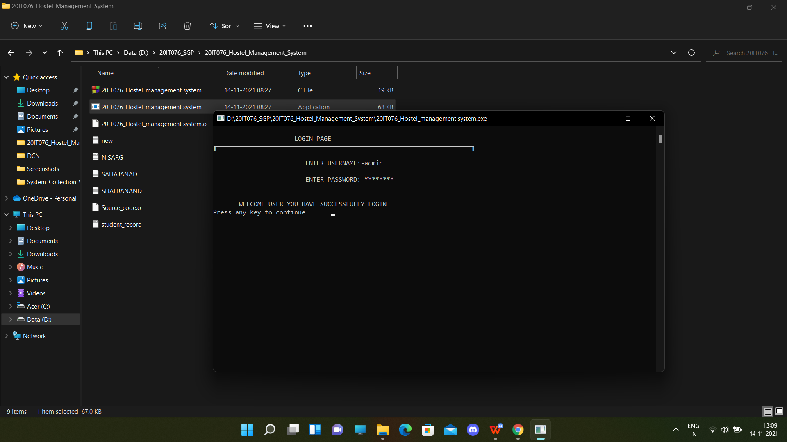

**MAIN MENU / NAVIGATOR BAR:**

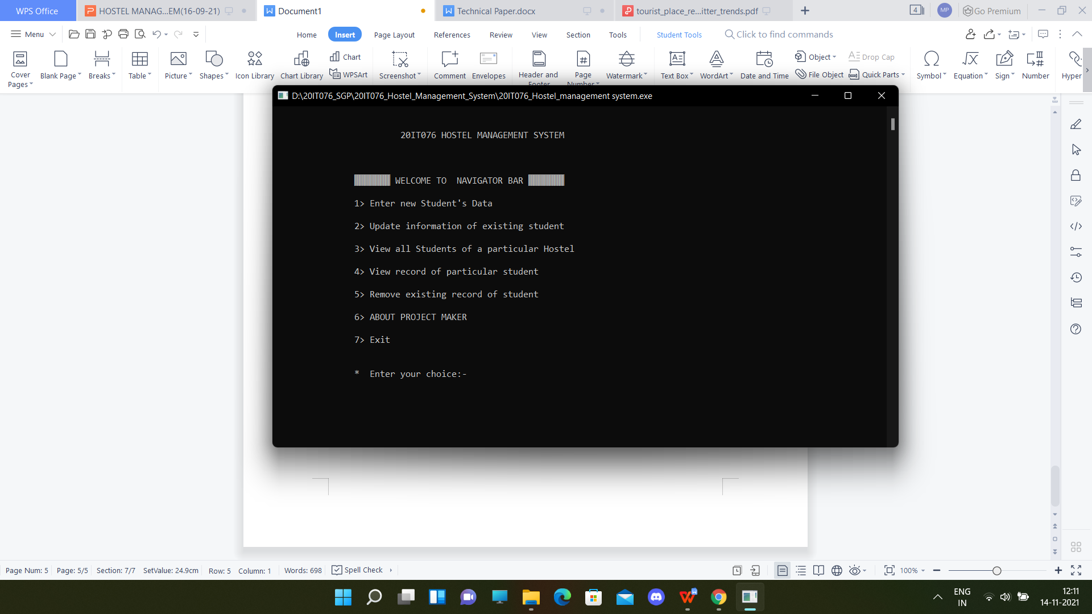

**All other things is in demo video.**

1. **CONCLUSION:**

To conclude the description about the project the Hostel management system has been developed to manage and automate the over-all processing of any Busy Hostel For the ease of the admin by saving time and the paperwork , so that data management or record management is maintained in a systematic way.

Hostel management system project is capable of managing hostel rooms records, Student records and etc.etc .

Hostel Management System is a user-friendly for hostel admin and is easy to use.

1. **FUTURE SCOPE:**

In future I will try to develop this system in any other language and platform with adding more modules and

Features apart from record management like mess management and students branch wise room management and will also add some attendance management too.

1. **Github link and blog link:**

<https://github.com/Mit076er/20IT076_SGP_1>

<https://20it076m076ersgp.blogspot.com/>